## WAVES WORKSHEET

## *Wave Behaviour*

**Reflection**

All waves are reflected when they strike a barrier in their path. They are reflected such that they obey the law of reflection: θi = θr, where θi is the angle of incidence (the angle between the normal and the incident ray) and θr is the angle of reflection (the angle between the normal and the reflected ray)

Complete the following diagrams by adding rays and wavefronts.

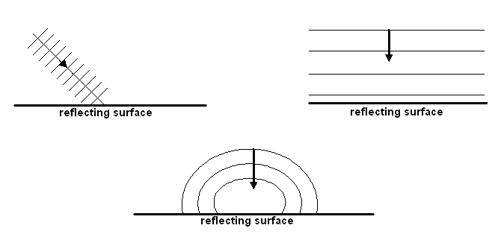

**Refraction**

Refraction is due to a change in velocity as a wave passes from one medium into another with differing wave characteristics (e.g. density). The frequency of the wave remains unchanged, but due to the change in velocity the wavelength changes and a bending effect can be observed if the ray enters the new medium at any angle other than 90°. The relationship between velocities (or wavelengths) and angles of incidence and refraction is expressed in Snell’s Law.

If the wave travels **faster** when it enters the new medium, it bends **away from** the normal (e.g. sound waves travelling from air into water).

If the wave travels **slower** when it enters the new medium, it bends **towards** the normal (e.g. light waves travelling from air into water).

Mechanical waves generally travel **faster in solids than in gases.**

Complete the following diagrams by adding rays and wavefronts.

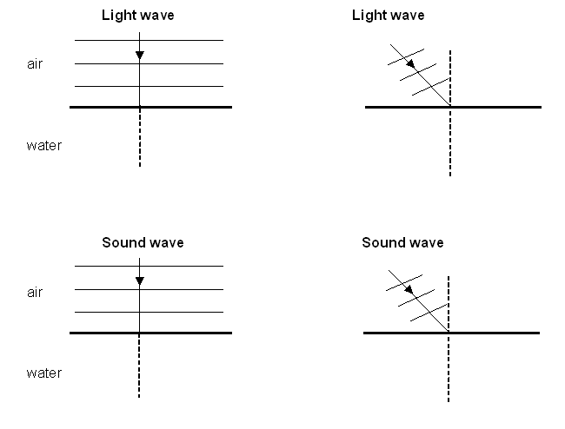

**Diffraction**

Diffraction is the outwards bending of waves as they pass through an opening (often called an *aperture*) or around the edge or edges of an obstacle. The amount of bending depends on the opening. If the wavelength is about the same as the size of the opening then maximum diffraction will occur. This helps to explain why you can hear someone through a door (wavelength of sound similar to width of a door) but you can’t see them (wavelength of light very small). In addition, higher frequency sound waves have shorter wavelengths, so they will diffract less than lower frequency sound waves with longer wavelengths.

**A Summary of Wave Behaviour**

|  |  |  |  |  |
| --- | --- | --- | --- | --- |
| **Behaviour** | **Cause** | **Unchanged** | **Changed** | **Application** |
| **Reflection** | change in direction as wave strikes a boundary | v, λ, f | direction | echoes and reverberation |
| **Refraction** | change in direction and speed of wave as a result of change in density of a medium | f | direction, λ, v (Snell’s Law) | skip zones |
| **Diffraction** | change in direction as a result of a wave passing through a gap or around an edge | v, λ, f | direction | hearing around corners and through gaps |

***Questions***

1. A sound wave has a frequency of 2.00 kHz, and the distance between two rarefactions is 0.175 m. How long will the wave take to reach an observer who is 200 m away?
2. In some old movies, people put their ear to the railway track to work out if there’s a train coming. Would this work? Explain your answer.
3. A group of scientists on holiday visit a canyon on a 25 °C day and decide to find out how wide the canyon is. They shout at the opposing wall and record how long it takes for them to hear the echo. They repeat the experiment five times and get the following results:

|  |  |
| --- | --- |
| **Trial** | **Time (s)** |
| 1 | 0.220 |
| 2 | 0.264 |
| 3 | 0.228 |
| 4 | 0.231 |
| 5 | 0.245 |

A few months later, the scientists visit the canyon again. This time, they enclose the entire canyon in a glass dome and fill it with helium. Would you expect the times they record to increase, decrease, or stay the same? Give a brief reason to justify your answer.

1. Using the space below, complete the following diagrams for **reflection** of waves at a harbour wall and the **refraction** of the sound of a bell as it enters the air from the water.

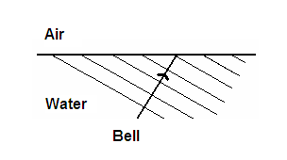

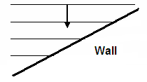

1. Sandy explodes a firework at position A which is 400 m from Jane at position B. Due to the echo from a wall, Jane hears two bangs which are 0.48 seconds apart. Calculate the perpendicular distance from the wall to Jane.

A (Sandy) B (Jane)

400 m

?

Wall

1. Jason is fishing from a jetty and notices that the float on his fishing line bobs up and down as regular waves pass by. He counts 12 full oscillations of the float in one minute.
2. What is the period of the water waves?
3. If he estimates the wavelength as 5 metres, calculate the speed of the wave.
4. An explosion on the ground sends sound waves through the air towards a rocky wall. The sound waves in the air are shown in the diagram below.
5. Draw the sound waves that have passed into the into the rocky wall. Your diagram should accurately represent any changes to the properties of the wave.

normal

rock

air

sound waves

1. Name the wave behaviour being shown in the diagram.
2. Carefully read the following report of the earthquake that shook Mexico City on 19 September 1985, then answer the questions below.

**Waves of destruction in Mexico City**

When the earthquake shook Mexico City on 19 September 1985, the worst-hit part of the city was an area that sits on the waterlogged sediments of an ancient lake. But within this area devastation was not uniform; buildings from 5 to 15 storeys high suffered the worst damage, and overall damage was distributed in alternate bands of heavy and light destruction.

All objects from piano strings to bridges and tower blocks have a resonant frequency at which they vibrate naturally. The 2-second period of the incoming shocks coincided with the resonance frequencies of tower blocks between 5 and 15 storeys high, which explains their vulnerability. But the zonation of damage suggests that these shock waves were reflected internally within the basin, interfered with each other and gave rise to standing waves (Nature, Vol 326, p 783).

Tremors are a complex mixture of up-and-down or side-to-side "shear” waves and back-and-fore “pressure" waves. Only the pressure waves move well through fluids or semi-solids. So the destruction in the region of the lakebed must have been caused by pressure waves. These waves originated locally, at the bottom of the sediment-filled basin, where about 30 percent of the energy from incoming shear waves would have been converted into pressure waves. Seismic data suggest the length of these pressure waves is 3 kilometres.

As the zones of maximum and minimum destruction were 750 metres apart, the observations fit the seismological prediction perfectly. Maximum collapses should be at the peak and trough of each wave, with minima at each end of the wave and at its central point, where displacement would have been at its lowest.

Researchers at the Instituto de Fisica in Mexico City now want to refine their model to determine more precisely the nature and direction of movement at every locality within the boundary of the lake. This should help engineers to ensure that new "earthquake-proof" buildings stand up rather better than their predecessors did.

1. State which waves in the article are longitudinal and which are transverse. Explain why.
2. What was the resonant frequency of the tower blocks that proved most   
   vulnerable to the quake?
3. Determine the velocity of a traveling seismic wave in the sediment-filled basin.
4. Using the seismic data offered in the third paragraph, explain why, in the fourth paragraph, the author is able to confidently assert that the 750-metre spacing of the maximum and minimum destructive zones 'fit the seismological prediction perfectly'.